Marine Scotland Science

NOTICE TO MARINERS

North Coast Smolt Tracking Acoustic Receiver Array

Issue date: Friday 10th February 2023

Marine Scotland Science (MSS) intend to install 21 acoustic fish tracking moorings in the Atlantic Ocean West of Orkney as part of North Coast Smolt Tracking Acoustic Receiver Array (figure 1). The moorings hold research equipment that support hydrophone receivers. These receivers will expand the West Coast Salmon Tracking Project and log the presence of Atlantic salmon and Sea Trout post-smolts which will be tagged with acoustic ID transmitter tags tagged by the Atlantic Salmon Trust (AST) and other institutes (should they pass within range).

The proposed locations of the fish tracking moorings are shown (Figure 1); the positions of the moorings are given in WGS84 (Table 1). The moorings will be deployed from the 13th of February 2023 by the RV Scotia. The moorings will be removed by the 30th of November 2023.

Acoustic fish tracking moorings (Figure 3) will not be surface marked and will be located on the seabed. The array moorings will extend vertically no more than 4 metres. The moorings will be recovered by boat, using the inbuilt acoustic recovery system. In the unlikely event of failure in the acoustic release system an ROV will be used from another boat to service the mooring. Should these be accidently caught only the instruments are required to be returned and the location of the discarded weight should be supplied to MSS for recovery later.

**Contact details**

All enquiries should be made to the Marine Scotland acoustics mailbox [acoustics@scotland.gsi.gov.uk](mailto:acoustics@scotland.gsi.gov.uk)) marked for the attention of Robert Main. Switch Board Tel: 0131 244 2500

Figure 1: Indicative location of North Coast Smolt tracking acoustic receiver array

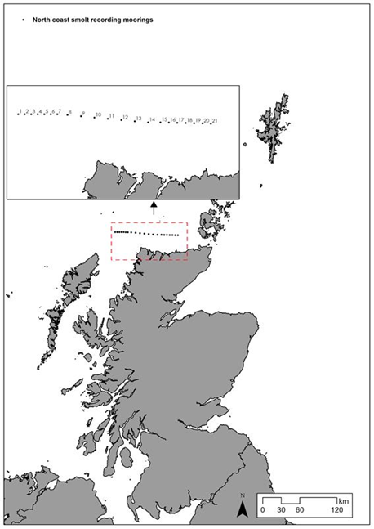

**Table 1: Mooring number and position**

|  |  |  |  |  |
| --- | --- | --- | --- | --- |
| ID | Decimal Latitude | Decimal Longitude | Lat (Deg dec min) | Lon(Deg dec min) |
| 1 | 58.8365 | -5.75 | 58° 50.19 N | 5° 45 W |
| 2 | 58.8376 | -5.6905 | 58° 50.256 N | 5° 41.43 W |
| 3 | 58.8386 | -5.6311 | 58° 50.316 N | 5° 37.866 W |
| 4 | 58.8397 | -5.5716 | 58° 50.382 N | 5° 34.296 W |
| 5 | 58.8408 | -5.5121 | 58° 50.448 N | 5° 30.726 W |
| 6 | 58.8419 | -5.4526 | 58° 50.514 N | 5° 27.156 W |
| 7 | 58.843 | -5.3932 | 58° 50.58 N | 5° 23.592 W |
| 8 | 58.8415 | -5.2995 | 58° 50.49 N | 5° 17.97 W |
| 9 | 58.8374 | -5.1762 | 58° 50.244 N | 5° 10.572 W |
| 10 | 58.8334 | -5.053 | 58° 50.004 N | 5° 3.18 W |
| 11 | 58.8293 | -4.9298 | 58° 49.758 N | 4° 55.788 W |
| 12 | 58.8253 | -4.8066 | 58° 49.518 N | 4° 48.396 W |
| 13 | 58.8212 | -4.6834 | 58° 49.272 N | 4° 41.004 W |
| 14 | 58.8172 | -4.5602 | 58° 49.032 N | 4° 33.612 W |
| 15 | 58.8188 | -4.4487 | 58° 49.128 N | 4° 26.922 W |
| 16 | 58.8185 | -4.3717 | 58° 49.11 N | 4° 22.302 W |
| 17 | 58.8182 | -4.2946 | 58° 49.092 N | 4° 17.676 W |
| 18 | 58.818 | -4.2176 | 58° 49.08 N | 4° 13.056 W |
| 19 | 58.8177 | -4.1405 | 58° 49.062 N | 4° 8.43 W |
| 20 | 58.8174 | -4.0635 | 58° 49.044 N | 4° 3.81 W |
| 21 | 58.8172 | -3.9865 | 58° 49.032 N | 3° 59.19 W |

**Figure 2: Pop-Up array mooring design**

Acoustic receiver with rope canister and floatation. AR type mooring.

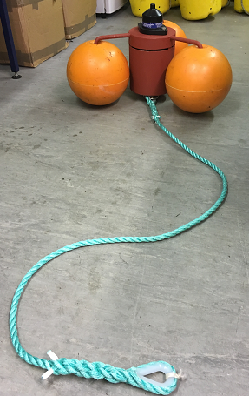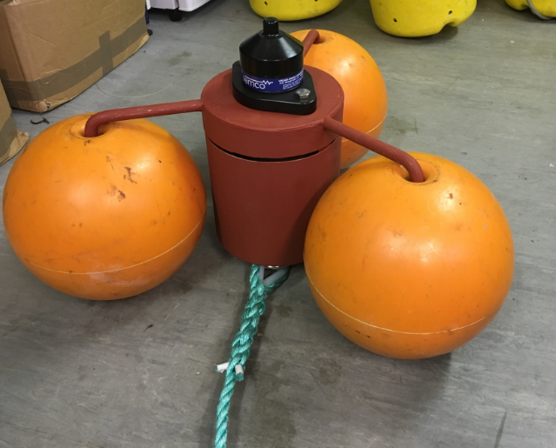

2 meters of Polysteel rope

70kg clump weight attached to bottom thimble