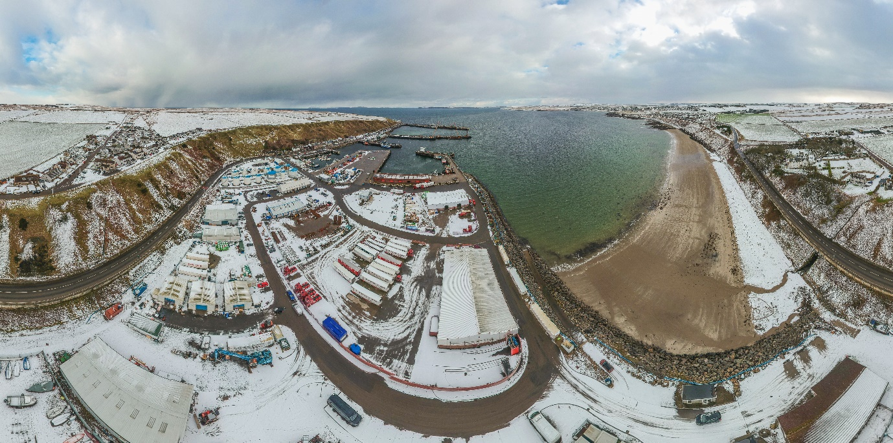

Merry Christmas from Scrabster Harbour