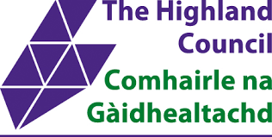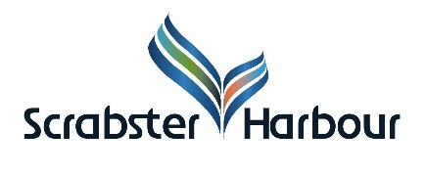
Notice to Mariners
There is currently a significant outbreak of a novel Coronavirus (COVID-19) affecting China and a number of other countries (See list of current risk area ) which has resulted in cases across the world, as well as on cruise ships. This situation has been declared a Public Health Emergency of International Concern by the World Health Organization Emergency Committee, under the International Health Regulations.
In response to this emerging situation regarding COVID-19 Health Protection Scotland and the Scottish Ports Liaison Network require a Maritime Declaration of Health (MDH) to be submitted to the Scottish Port Health Authority of the ports in the table below in the following cases irrespective of whether the vessel is arriving from a foreign port or another UK port:
- Cruise Vessels

  - ALL cruise vessels

- Container and Cargo Vessels

  - where anyone on board the vessel has travelled from or via any current risk area or if they have been in close contact with confirmed case of COVID-19 infection within the 14 days prior to the vessel arriving in a Scottish Port.
In the MDH the Master of the vessel should also indicate the origin of the ship, when it left the origin port, and all ports where the vessel has docked during the 14 days prior to arrival.
Symptoms of COVID-19 may include fever or acute respiratory infection with at least one of cough, sore throat, or shortness of breath. The Master of the ship should consider these as grounds for suspecting the existence of a disease of an infectious nature in addition to those listed on the current MDH.
Where a port operator or ship’s agent receives notice that there are ill persons on a vessel then:
If the suspected case is a medical emergency, you must call 999 for medical assistance and you must inform attending services that the case has originated from a COVID-19 risk area or has had contact with a confirmed case. DO NOT disembark the patient or arrange alternative transport to a hospital until advised to do so. Also ask the Harbour Master to inform the NHS Public Health (local Health Protection Team) and the Port Health Authority (the local authorities).
If the suspected case is not seriously ill you must notify the relevant NHS Health Protection Team on (See list below). Contact details for the case must be provided with sufficient information to allow the Health Protection Team to determine follow up action. This will include symptoms, duration, contacts and travel history. DO NOT disembark the suspected case.
Further information can be found on the Health Protection Scotland and World Health Organization websites.

The following are the contact details for submitting your Maritime Declaration of Health:
Please note that Highland Council, Environmental Health are the Port Health Authority for the following port/location:

Port/Location | Telephone Number | Email Address | Marine Radio
Scrabster (all facilities) | 01349 886606 | envhealth@highland.gov.uk | None
Scrabster Harbour | 01847 892779 | OPS ops@scrabster.co.uk | Port Control VHF Channels 12

Further Information:
Health Protection Scotland
https://www.hps.scot.nhs.uk/a-to-z-of-topics/wuhan-novel-coronavirus/
https://www.hps.scot.nhs.uk/web-resources-container/novel-coronavirus-2019-ncov-risk-areas/
World Health Organization
https://www.who.int/emergencies/diseases/novel-coronavirus-2019

In the event of any changes to risk areas this link will be updated

